Distributor  Webcam Distributor Proposal  Effective: 1st of January, 2006 | 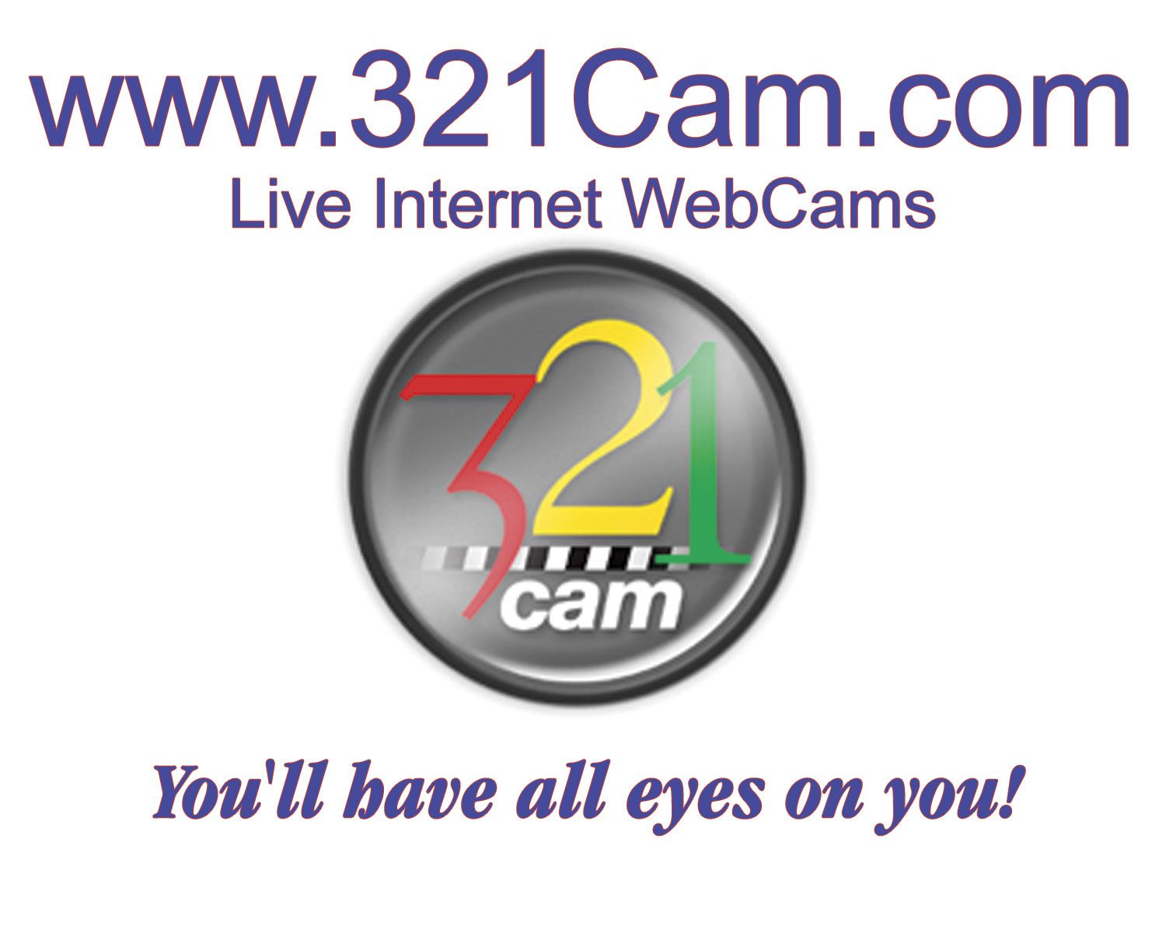
Youremailaddressgoeshere@yourcompany.com

Table of Contents

Distributor Webcam Distributor Proposal 1st of January, 2006 1
Description of Services 3
Definitions 4
Comments, Suggestions, Options and Plans 5
Main Products 6
Other Products/Services: 8
Acceptance 9
Picture of the Webcam and remote control base 10
Picture of the option to increase the distance to 300 feet 11

Description of Services

This Statement of Work (“SOW”) is an Agreement dated (today’s date will go here),
by and between NannyCam.net/321Cam.com (“Provider”) and (“Client”).

Client’s Project Representative | 321Cam.com
Name: your name | Name: Steve Cook
Organization:  your company | Company:  NannyCam.net / 321Cam.com
Phone  Tel/Fax.  Cel. | Phone: 1 (651) 483-8300
Fax: | Fax: 1 (931) 443-8300
E-mail: | E-mail: manager@321cam.com and/or  steve@nannycam.net
Address: | Address: 321Cam.com  1138 Hunters Ct.  St. Paul, MN 55112-3710  USA

Summary
You can distribute systems anywhere you want to, with you specializing in your country of (your country goes here).

321Cam.com will:
Provide any number of webcam video systems and parts upon payment.

Client will:
- Determine what internet connection will be used
- Order product/services based upon the remote sites internet connection
- Provide internet access at location
- Provide pc (desktop, laptop, notebook). Details of pc below.

Definitions
Broadcaster (Client):
Broadcaster is someone with a video device/system that transmits images to the internet.

Viewer:
Anyone with an IBM compatible PC with an Internet connection to watch the broadcasters video images.

Website:
Client can put links on any website to the live cameras.

321Cam responsibilities will include delivering any system within 2 weeks once paid for:

(Broadcaster) minimum PC recommendation for each webcam security system:
- Desktop with these minimum system requirements per security system:
  - Windows 98 second edition, ME (millennium), 2000, XP home, XP Pro
  - Intel Pentium, Pentium II, Pentium III, Pentium IV and faster
AMD K6, AMD K6-2 133 MHZ and faster (200 MHZ or faster recommended
  - 32 MG (megabytes) of RAM (memory)
  - 2 USB ports per video system (only 1 needed if using a USB extender)
  - CD rom drive for software installation (or download software from http://www.321cam.com/videosolutions/SurveillanceSoftware.htm)
  - Monitor capable of 24 bit color at 64 x 480 or more
  - Windows compatible sound card and also microphone if you want to hear and talk. If you don't need to hear and talk, then no sound card or speakers needed. Talking and hearing is only one on one using the “Buddy” feature.
  - Internet access: You will need an internet connection. Preferably broadband such as a corporate network, DSL, cable modem or similar, especially if you have more than one video system at the same location
  - Internet Explorer 6.0 or higher
  - 20 megabytes available hard disk space
Anyone trying to view the live video minimum PC recommendation:
- IBM compatible PC
- Connection to the internet
- Windows 98 and above operating system
- Internet Explorer 5+ and/or Netscape Navigator 4.6+
- 12 megs free disk drive space
- We have both Java and non-Java versions and these are an example: (these two go to the same video camera, and the video camera is normally running only on weekdays).
- http://24.118.41.204:8090/remote6/
- http://24.118.41.204:8090/Remote/index.php3

Comments, Suggestions, Options and Plans

Webcam
Logitech QuickCam Pro 4000 is the recommended webcamera for our software.
Digital Camcorder
You can purchase your own video digital camcorder.
Camcorder Models Compatible with Optical Zoom Control
At present, these are the camcorder models we know of that work with optical zoom control:
CanonZR series (Canon MV in Europe)
CanonElura series
CanonOptura
PanasonicNV-GS70

Longer distance option
Extends the video signal up to 300 feet:
- see below for details

Refresh rates:
- 1 second. Approximate only because it depends on the internet traffic and dependant on broadcaster and also the viewers and broadcasters internet connection speed and also the speed of their computer and lastly how many video systems are going through your one internet connection.

Misc.
There can be up to 4 webcam video systems on one pc, but that might be a little more complicated than the girls want to handle. You can buy cheap used PC’s from us similar to the one I run 24/7 for my Puppycam. To see it go to the home page at 321cam.com and click on the puppy. The 4 in 1 does not work with the camcorder video system yet.

Currency Converter.
http://www.321cam.com/misc/CurrencyConverter.htm

Broadcaster/Client:
You have the ability to do many things such as:
- Insert a webcam video into your own website such as we do here at this link http://www.netmeeting.us/PuppyCam.htm

- Insert the “Viewer” into your own website:
http://www.321cam.com/webmaster/Webmaster.htm#viewer
That way people will be able to sign up on your own website instead of going to ours. This is a brand new feature and you would be the first one to get it.

Main Products

Shipping charges will be determined based upon quantity and destination.
For an estimate, please send us an email of what you want to order and the shipping address.
Prices subject to change at anytime.

Product | Product Description | Unit Price | Qty
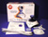 | Retail  Each in nice Retail Box with documentation, Software on CD etc… | Robotic Tripod & Software  (Camera Not Included)
  Dealer Price:
  QTY 5 - 24: | US$157.50
  QTY 25 - 49: | US$150.00
  QTY 50 - 99: | US$135.00
  QTY 100 - 199: | US$128.75
  QTY 200+: | US$120.00
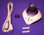 | Non-Retail  Each in Brown Box | Brown boxes each containing: Robotic Tripod, USB cable, camera shoe, 2 screw legs, one year manufacturer warranty card  (Not Included: Camera, Box, Software CD)
  Dealer Price:
  QTY 5 - 24: | US$120.00
  QTY 25 - 49: | US$110.00
  QTY 50 - 99: | US$95.00
  QTY 100 - 199: | US$92.00
  QTY 200+: | US$85.00
 | Bulk Pack | Robotic Tripod, USB cable, camera shoe, 2 screw legs, one year manufacturer warranty card, without individual packaging  (Camera Not Included)
  QTY 25 - 49: | US$100.00
  QTY 50 - 99: | US$93.75
  QTY 100 - 199: | US$87.50
  QTY 200+: | US$82.25
  ……………………………….
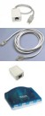 | CAT5 Extender  With cable including 150 feet of cat5 cable  Extends up to 4 USB devices. | USB to CAT5 converter, CAT5 to USB converter, USB A-B cable, 4-port Powered USB hub, to extend base and camera up to 150 feet FROM computer
  Dealer Price:
  QTY 5 - 24: | US$150.00
  QTY 25 - 49: | US$140.00
  QTY 50 - 99: | US$130.00
  QTY 100 - 199: | US$125.00
  QTY 200+: | US$120.00
 | Heavy Duty base for non-Sony Camcorders in Brown Box | Brown boxes each containing: PowerPod robotic tripod, USB cable, camera shoe, tripod mount, one year manufacturer warranty card. (Camcorder not included.)
  Dealer Price:
  QTY 5 - 24: | US$140.00
  QTY 25 - 49: | US$130.00
  QTY 50 - 99: | US$125.00
  QTY 100 - 199: | US$110.00
  QTY 200+: | US$102.00
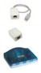 | CAT5 Extender  (no cable)  Extends up to 4 USB devices up to 150 feet. | USB to CAT5 converter, CAT5 to USB converter, USB A-B cable, 4-port Powered USB hub, to extend base and camera up to 150 feet FROM computer
  Dealer Price:
  QTY 5 - 24: | US$115.00
  QTY 25 - 49: | US$110.00
  QTY 50 - 99: | US$100.00
  QTY 100 - 199: | US$95.00
  QTY 200+: | US$90.00
 | Logitech QuickCam Pro 4000  Works well in low light because the main difference between webcams is the light-sensitive chip found inside.  Most webcams including all the cheap ones, and also some expensive ones have a so-called CMOS chip. This is not as sensitive as the higher-quality CCD chip found in this webcam. | Logitech QuickCam Pro 4000 USB webcam CCD 640x480 camera with driver. mounting stand not included, but mounts easily onto our remote control base.
  Dealer Price:
  QTY 5 - 24: | US$90.00
  QTY 25 - 49: | US$85.00
  QTY 50 - 99: | US$80.00
  QTY 100 - 199: | US$75.00
  QTY 200+: | US$70.00
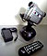 | Heavy Duty Base-IR (Infra-Red) in Brown Box | Brown box containing: Heavy Duty Base-IR (Infra-Red) robotic tripod, power supply, IR remote control, camera shoe, tripod mount, one year manufacturer warranty card. (Camcorder not included.)
  Dealer Price:
  QTY 5 - 24: | US$150.00
  QTY 25 - 49: | US$140.00
  QTY 50 - 99: | US$130.00
  QTY 100 - 199: | US$120.00
  QTY 200+: | US$112.00
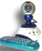 | Remote Control-IR (Infra-Red) in Brown Box | Brown boxes each containing: Remote Control Base-IR robotic tripod, power supply, IR remote control, camera shoe, tripod mount, one year manufacturer warranty card. (Camera not included.)
  Dealer Price:
  QTY 5 - 24: | US$130.00
  QTY 25 - 49: | US$120.00
  QTY 50 - 99: | US$110.00
  QTY 100 - 199: | US$100.00
  QTY 200+: | US$92.00
 | Heavy Duty base / LANC for Sony Camcorders in Brown Box | Brown boxes each containing: Heavy Duty base for Sony Camcorders /-LANC robotic tripod, USB cable, camera shoe, tripod mount, one year manufacturer warranty card. (Camcorder not included.)
  Dealer Price:
  QTY 5 - 24: | US$150.00
  QTY 25 - 49: | US$140.00
  QTY 50 - 99: | US$130.00
  QTY 100 - 199: | US$120.00
  QTY 200+: | US$112.00

Shipping charges will be determined based upon quantity and destination.
For an estimate, please send us an email of what you want to order and the shipping address.
Prices subject to change at anytime.

Other Products/Services:

Program Task | Pricing Estimate
Webmaster. VIEWER. Want drive traffic to your own website? Purchase our webmaster permissions and you can insert our viewer into your own website.  Details at  http://www.321cam.com/webmaster/Webmaster.htm#viewer | One-time charge $ 19.99 each
Webmaster. WEBSITE. We can develop and host your website.  Details at  http://www.321cam.com/misc/WebsiteDevelopment.htm  Programming:  http://www.allhomebased.com/Custom_Programming.htm | One-time charge  $100.00 5 pages $300.00 20 pages
Shipping.  Once you have an order and you are ready to place it, please send it to me by email or fax. Then I can estimate the shipping charges, and you will confirm it by email too.  Currency Converter  http://www.321cam.com/misc/CurrencyConverter.htm | We also accept Western Union for payment. See the Western Union logo on our products page (towards the bottom).  http://www.321cam.com/videosolutions/Products.htm
Software:
You can download the software right now for free. It will give you warning messages about not having a base/pod but you still can see if your webcam will work.
http://www.321cam.com/videosolutions/SurveillanceSoftware.htm

Acceptance

4.1 Provider Fees

Client agrees to pay Provider (TBD) for the products before we ship them. Payment can be made by Western Union, Bank Drafts, Cashiers Checks and Personal Checks. All prices on the website are in US dollars, you can use our currency converter if you want at this webpage
http://www.321cam.com/misc/CurrencyConverter.htm

Terms:

Agreed and Accepted: | Agreed and Accepted:
321Cam.com | Your company
By: | By: your name
Printed Name: Steve Cook | Printed Name: your name
Title: President | Title:
Date: | Date:

Picture of the Webcam and remote control base
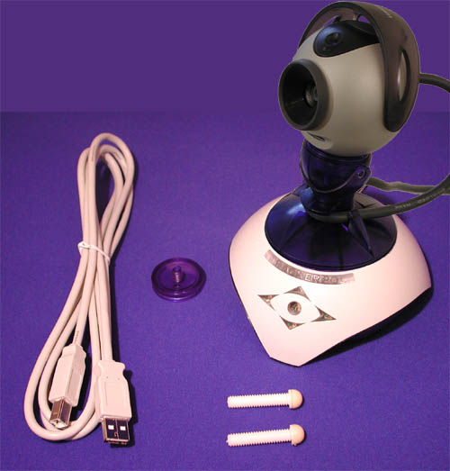

Picture of the option to increase the distance to 300 feet
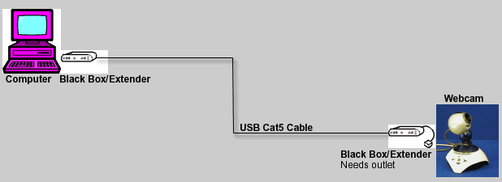

Multi Cam video window
